BLACKROTH MICROSERVICES
EPIC 07 — TASK 04
Distributed Tracing, Correlation IDs
& Structured Logging

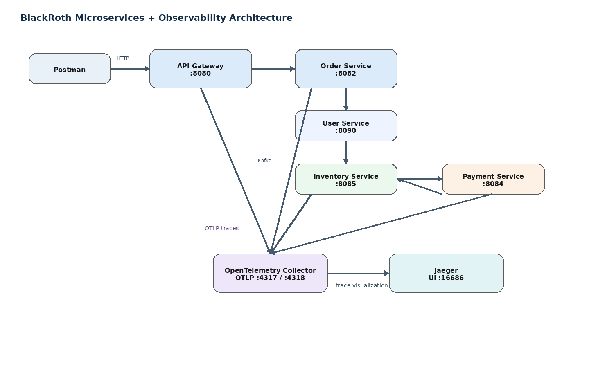
Implementation + Learning + Evidence + Troubleshooting Reference
Project: microservices-architecture-fundamentals
Technology focus: Spring Boot 4.1.1 • Java 25 • Kafka • MySQL • Redis • OpenTelemetry • OTLP • OpenTelemetry Collector • Jaeger
Completion date: 08 October 2026
Git checkpoint: 5b514af — feat: add OpenTelemetry distributed tracing

Contents
- 1. Task Overview
- 2. Learning Objectives
- 3. Existing Microservices Architecture
- 4. Why Distributed Tracing Is Needed
- 5. Core Concepts: Trace, Span and Context
- 6. Trace ID vs Span ID vs Correlation ID
- 7. Structured Logging
- 8. Correlation-ID Implementation
- 9. HTTP Propagation
- 10. Kafka Propagation
- 11. OpenTelemetry
- 12. OpenTelemetry Java Agent
- 13. W3C Trace Context and traceparent
- 14. OTLP, Collector and Jaeger
- 15. End-to-End Observability Architecture
- 16. Successful Request Workflow
- 17. Jaeger Trace Analysis
- 18. Inventory State and Payment Completion
- 19. Failure and Recovery Workflow
- 20. Payment Completion Idempotency
- 21. Testing and Validation
- 22. Troubleshooting Guide
- 23. Git / Version-Control Checkpoint
- 24. Completion Status
- 25. Glossary
- 26. Final Summary
- Appendix A — Evidence Register
- Appendix B — Key Configuration
Reading strategy: Sections 1–15 explain the concepts and implementation from first principles. Sections 16–23 connect those concepts to the actual test evidence. The appendices provide the evidence index and configuration reference.

1. Task Overview
Task 04 extends the BlackRoth Spring Boot microservices platform with distributed request visibility. The goal is to make a request traceable across synchronous HTTP calls, asynchronous Kafka events, database operations and service boundaries.
The implementation combines two complementary mechanisms:
- Application/business correlation using the X-Correlation-ID header and Kafka record headers.
- Technical distributed tracing using OpenTelemetry, W3C Trace Context, OTLP, the OpenTelemetry Collector and Jaeger.
The result is a system in which a single order can be followed from Postman → API Gateway → Order Service → Inventory Service → Payment Service → Order Service, while logs and trace spans provide different levels of diagnostic detail.

Objective
Create an evidence-backed observability workflow that can be understood, tested, and troubleshot without relying on undocumented assumptions.

Scope
Area | Implemented / Verified
Correlation ID | X-Correlation-ID generated/accepted at Gateway and propagated through services.
Structured-style logs | Consistent fields for correlation ID, method, URI/endpoint, status and duration.
HTTP tracing | OpenTelemetry Java Agent instrumentation and W3C trace context.
Kafka tracing | OpenTelemetry Kafka instrumentation plus application correlation headers.
Telemetry pipeline | OTLP → OpenTelemetry Collector → Jaeger.
Business outcome | Inventory reservation, payment completion, sold quantity and order confirmation verified.
Failure/recovery | Payment failure/recovery path observed and traced at application level.
Idempotency | ProcessedPaymentCompletion protection verified in trace/log evidence.

2. Learning Objectives
- Understand observability in a distributed system.
- Explain a trace and a span.
- Understand trace context and W3C traceparent.
- Distinguish trace ID, span ID and application correlation ID.
- Understand HTTP and Kafka context propagation.
- Understand structured logging and its limitations in the current implementation.
- Understand the role of OpenTelemetry and the Java Agent.
- Understand OTLP and the Collector.
- Use Jaeger to inspect a distributed trace.
- Trace failures and explain asynchronous recovery.
- Verify business state with MySQL alongside telemetry.
- Maintain an auditable Git checkpoint.

3. Existing Microservices Architecture
Figure 1 — Overall BlackRoth microservices and observability architecture.
The application consists of API Gateway, User, Product, Order, Payment, Inventory and Notification services. The order workflow is the main observability scenario used in this task.
Service | Port / Role | Relevant interaction
API Gateway | :8080 | External entry point; routes requests and owns client-facing correlation response header.
User Service | :8090 | Called synchronously by Order Service.
Product Service | :8081 | Independent product API; not central to the tested order trace.
Order Service | :8082 | Creates orders and publishes/consumes order/payment events.
Payment Service | :8084 | Consumes inventory-reserved and publishes payment-completed.
Inventory Service | :8085 | Reserves inventory and completes sale after payment.
Notification Service | Kafka consumer | Consumes order-created for notification processing.

4. Why Distributed Tracing Is Needed
In a monolithic application, one log stream may be enough to follow a request. In a microservices system, the request crosses processes, threads, HTTP boundaries, Kafka topics and database calls. A timestamp alone does not prove that two log lines belong to the same business operation.
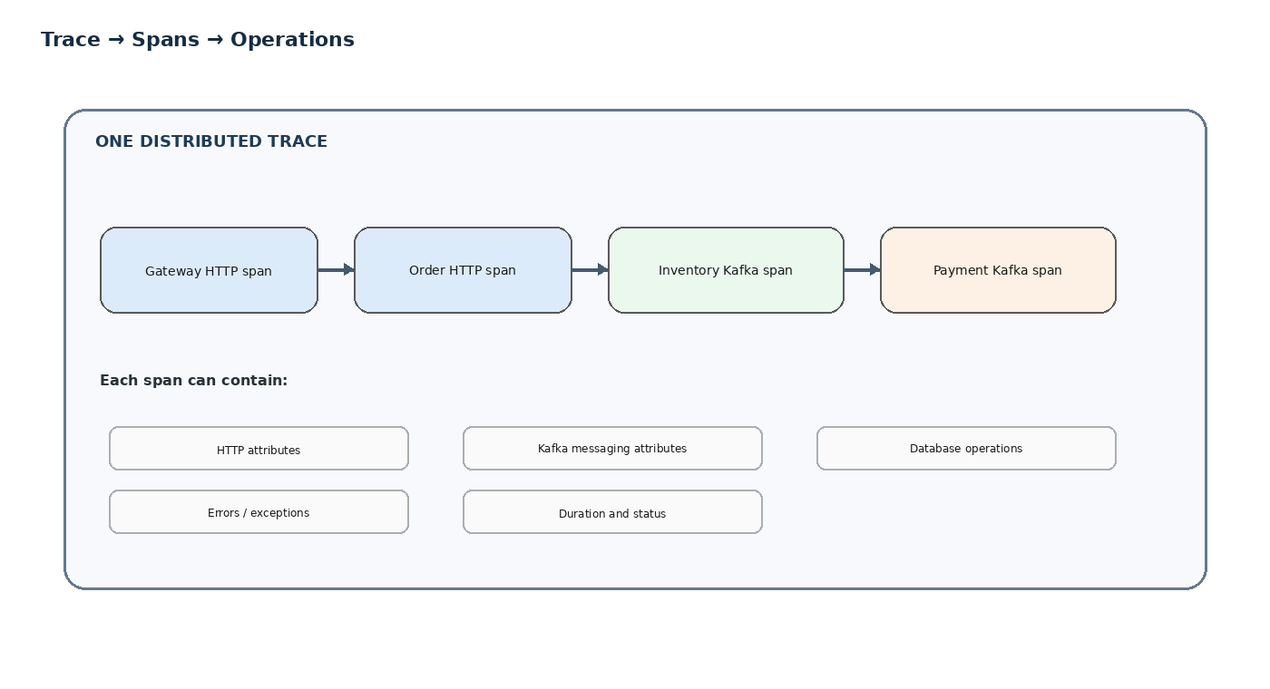
Figure 2 — A trace is a tree of individual spans/operations.
The operational question changes from “Did the order service work?” to “Where did this specific order spend time, which downstream operation failed, and which asynchronous event caused the final state transition?”
- Logs answer: what did the application report?
- Correlation IDs answer: which application messages belong together?
- Traces answer: what operations occurred, in what parent/child relationship, and how long did they take?

5. Core Concepts: Trace, Span and Context

5.1 Trace
A trace represents the complete distributed journey of one logical request or business operation. In this project, an order trace can span Gateway, Order, Inventory and Payment and can include database and Kafka operations.

5.2 Span
A span represents one operation inside the trace. Examples observed in Jaeger include HTTP server spans, Kafka producer/consumer spans, repository/database spans and transaction commits.

5.3 Trace Context
Trace context is the information carried between components so that downstream work can be associated with the correct trace. In this task, OpenTelemetry manages W3C trace context rather than the application manually constructing traceparent.

5.4 Parent-child relationship
A parent span represents the operation that caused another operation. For example, an Order Service operation can produce an order-created Kafka span, which is followed by an Inventory Service consumer span.

6. Trace ID vs Span ID vs Correlation ID
Identifier | Purpose | Managed by | Example
Trace ID | Identifies the complete distributed trace. | OpenTelemetry | Visible in Jaeger trace URL/details.
Span ID | Identifies one operation within the trace. | OpenTelemetry | Visible on an individual Jaeger span.
X-Correlation-ID | Application/business identifier used to correlate logs and message processing. | Application code | OTEL-GATEWAY-TEST-002
traceparent | W3C header carrying trace context between services. | OpenTelemetry | Generated/propagated by OTel.
These identifiers should not be treated as interchangeable. The project deliberately keeps X-Correlation-ID for application-level troubleshooting while OpenTelemetry owns technical trace/span context.

7. Structured Logging
Structured logging means that logs contain predictable fields that can be searched and interpreted consistently. The current implementation uses consistent pipe-delimited fields rather than JSON.
Correlation ID: OTEL-GATEWAY-TEST-002 | Method: POST | URI: /api/v1/orders | Status: 201 | Duration: 2203 ms

Important accuracy note: these logs are structured-style logs, not JSON logs. The distinction is documented intentionally so that the task does not overstate the implementation.
The application filters log the correlation ID, HTTP method, endpoint/URI, response status and elapsed time. Gateway also identifies the target service from the route.

8. Correlation-ID Implementation
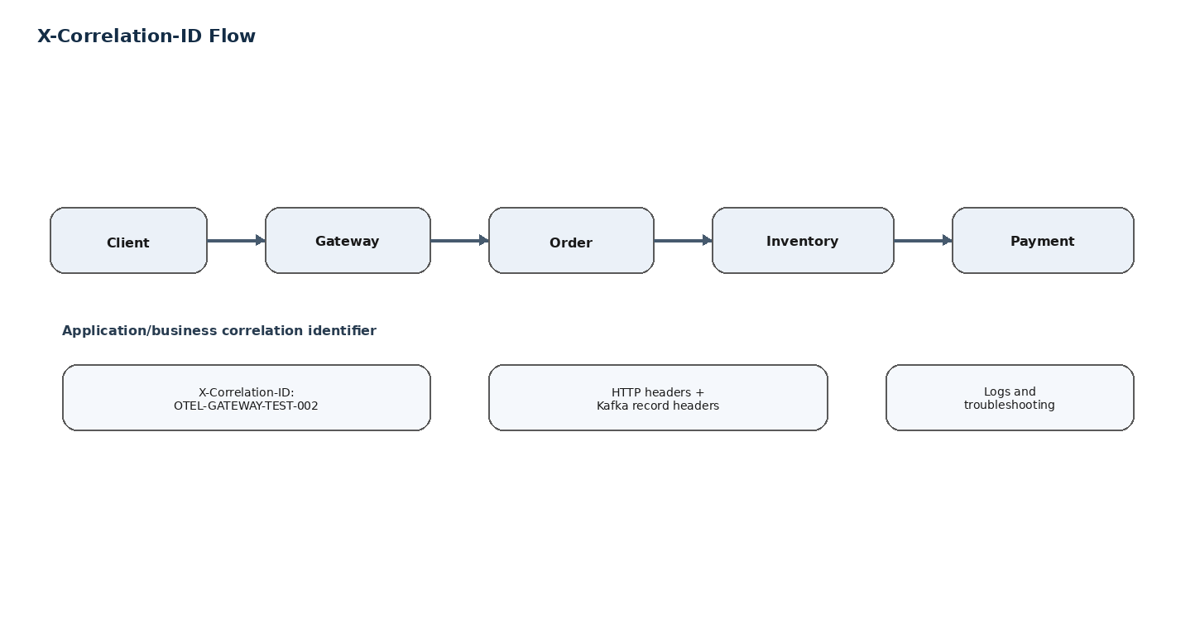
Figure 3 — Application-level X-Correlation-ID propagation.
The Gateway owns the client-facing X-Correlation-ID response header. If a valid incoming value exists, it is reused; otherwise the Gateway generates a UUID. Downstream filters read the same value and place it into the request context for application logging and outgoing propagation.

Key design decision
Downstream services do not independently generate a new response header. This avoids duplicate response-header behavior and keeps Gateway as the client-facing owner of X-Correlation-ID.

9. HTTP Propagation
HTTP propagation has two separate concerns in this project:
- X-Correlation-ID is propagated by application code and the Order Service RestTemplate interceptor.
- OpenTelemetry propagates W3C trace context automatically through supported HTTP instrumentation.
request.getHeaders().set("X-Correlation-ID", correlationId.toString());

This means the business correlation value and the OpenTelemetry trace context travel together, but they remain logically separate mechanisms.

10. Kafka Propagation
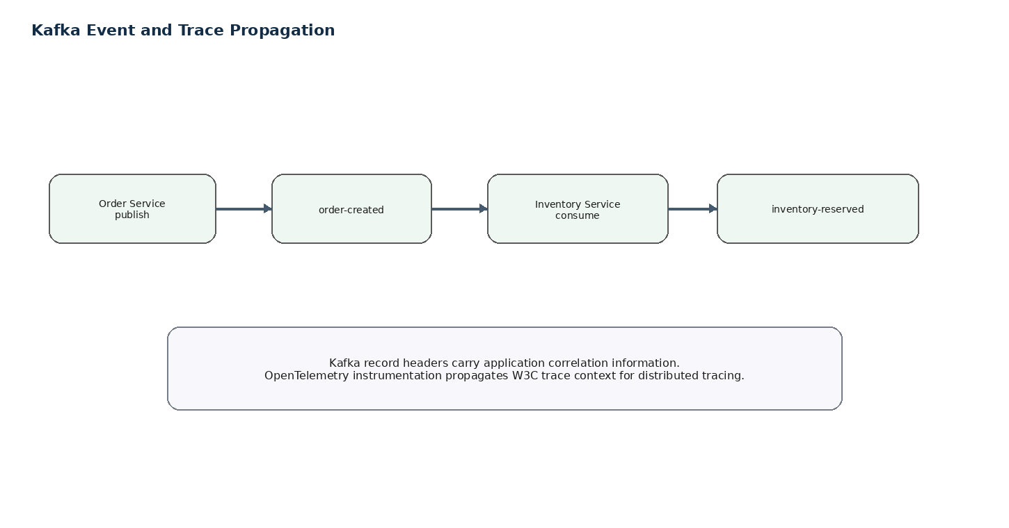
Figure 4 — Kafka event flow and application correlation.
Kafka is asynchronous, so there is no HTTP request object available at the consumer. The application therefore writes X-Correlation-ID into Kafka record headers when publishing and reads it from the ConsumerRecord when consuming.
ProducerRecord<String, String> record = new ProducerRecord<>(topic, payload);
record.headers().add("X-Correlation-ID", correlationId.getBytes(StandardCharsets.UTF_8));

The tested business chain is order-created → inventory-reserved → payment-completed, with the application correlation value retained across those events. OpenTelemetry Kafka instrumentation supplies the distributed tracing context.

11. OpenTelemetry
OpenTelemetry is the observability framework used here to generate and export telemetry. The project uses the Java Agent to instrument supported application/framework operations with minimal application-code changes.
Conceptually:
Spring Boot service
↓
OpenTelemetry Java Agent
↓
Instrumentation creates spans
↓
OTLP export
↓
OpenTelemetry Collector
↓
Jaeger

This separation is valuable because application code remains focused on business behavior while telemetry generation is handled by instrumentation.

12. OpenTelemetry Java Agent
The Java Agent used during the implementation reported version 2.32.0 in the service startup/debug evidence. Services were started with -javaagent and service-specific resource attributes.
java "-javaagent:C:\Users\DELL\microservices-architecture-fundamentals\observability\opentelemetry-javaagent.jar" `
"-Dotel.service.name=api-gateway" `
"-Dotel.exporter.otlp.endpoint=http://localhost:4317" `
"-Dotel.exporter.otlp.protocol=grpc" `
"-Dotel.resource.attributes=service.namespace=blackroth,deployment.environment=local" `
"-Dotel.logs.exporter=none" `
"-Dotel.metrics.exporter=none" `
"-jar" "target\api-gateway-0.0.1-SNAPSHOT.jar"

Option | Meaning
-javaagent | Attaches the OpenTelemetry Java instrumentation agent.
otel.service.name | Sets the service identity shown by the telemetry backend.
otel.exporter.otlp.endpoint | Sends OTLP telemetry to the local Collector.
otel.exporter.otlp.protocol=grpc | Uses OTLP over gRPC to port 4317.
otel.resource.attributes | Adds common namespace/environment resource metadata.
otel.logs.exporter=none | Logs are not exported through the OTel log exporter in this local setup.
otel.metrics.exporter=none | Metrics export was disabled for this task; tracing is the focus.

Evidence 01 — OpenTelemetry Java Agent debug instrumentation
Purpose: Verify that the Java Agent is active and transforming/instrumenting application classes.
Observed result: The terminal shows [otel.javaagent ...] DEBUG messages and instrumentation activity, confirming the agent is attached to the running JVM.
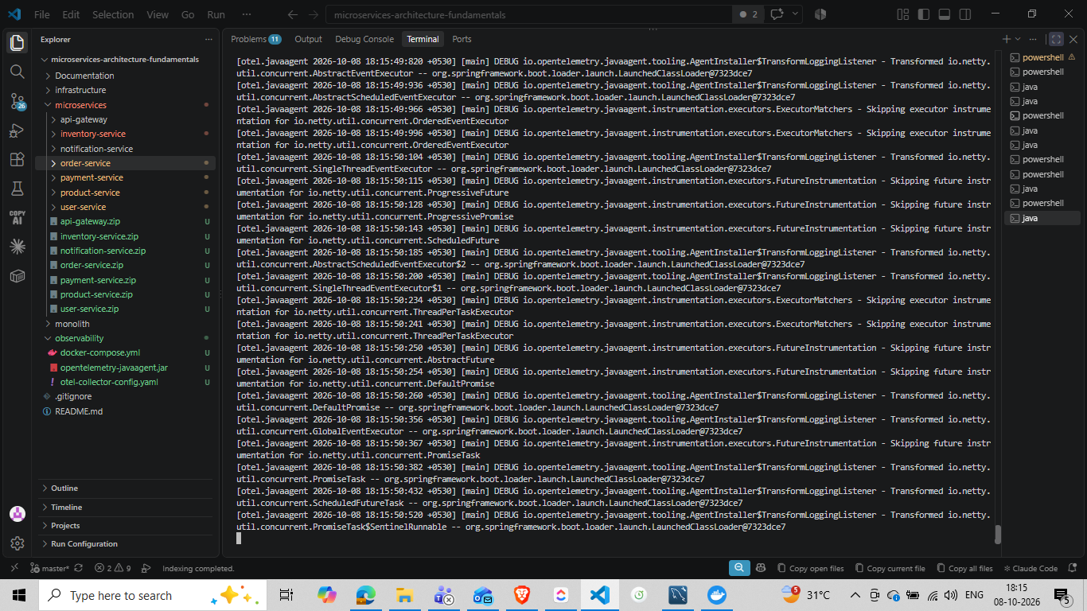
Evidence screenshot — user-provided project evidence.
Interpretation: This evidence is included to show what was actually observed during the implementation/test run; it is not a generic example.

13. W3C Trace Context and traceparent
W3C Trace Context standardizes how distributed tracing context is carried across process boundaries. The central header is traceparent. The application does not manually construct it.
Figure 5 — Trace context connects spans across service boundaries.
In this implementation, Postman can supply X-Correlation-ID for business correlation. OpenTelemetry establishes and propagates the technical trace context. This prevents application code from having to manage low-level trace IDs and parent span IDs itself.

14. OTLP, Collector and Jaeger
OTLP is the protocol used to export OpenTelemetry telemetry. The local Collector listens on 4317 (gRPC) and 4318 (HTTP). Jaeger provides trace storage/visualization for the exported traces in this local environment.
Component | Local role | Port
OpenTelemetry Collector | Receives OTLP and forwards traces. | 4317 / 4318
Jaeger | Trace backend and UI. | 16686 UI
Jaeger OTLP receiver | Receives traces from Collector in this setup. | 4317 inside Docker network
The Collector is deliberately kept between applications and Jaeger. This makes the application telemetry pipeline vendor-neutral and allows the backend to change without changing every service.

15. End-to-End Observability Architecture
Figure 6 — End-to-end architecture.
The architecture separates business processing from observability transport. HTTP and Kafka carry the business workflow. OpenTelemetry produces trace telemetry. OTLP carries that telemetry to the Collector. Jaeger is used to inspect the resulting traces.

16. Successful Request Workflow
A successful order test used correlation ID OTEL-GATEWAY-TEST-002 and returned HTTP 201 Created. The flow was:
- Postman sent POST /api/orders through API Gateway.
- Gateway accepted/returned X-Correlation-ID OTEL-GATEWAY-TEST-002.
- Order Service created the order and published order-created.
- Inventory Service consumed the event and reserved inventory.
- Inventory Service published inventory-reserved.
- Payment Service processed the payment and published payment-completed.
- Inventory Service completed the sale and increased sold quantity.
- Order Service consumed PaymentCompleted and moved the order to CONFIRMED.
- Notification Service consumed order-created for notification processing.

Evidence 02 — Successful order request in Postman
Purpose: Verify the externally visible result and correlation header.
Observed result: The request returned 201 Created and the response contained X-Correlation-Id: OTEL-GATEWAY-TEST-002.
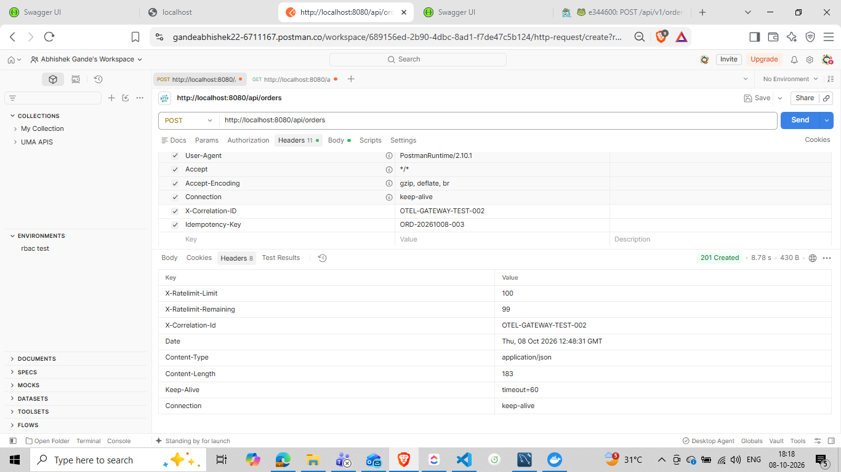
Evidence screenshot — user-provided project evidence.
Interpretation: This evidence is included to show what was actually observed during the implementation/test run; it is not a generic example.

17. Jaeger Trace Analysis
Jaeger provides a visual tree of the trace. The evidence captured during testing shows API Gateway as the root span in the successful distributed trace and child spans for Order and Inventory operations.

Evidence 03 — Jaeger distributed trace: API Gateway → Order → Inventory
Purpose: Verify that one trace contains multiple services and downstream operations.
Observed result: Jaeger shows api-gateway: POST /api/orders/** with child Order Service and Inventory Service operations and database activity.
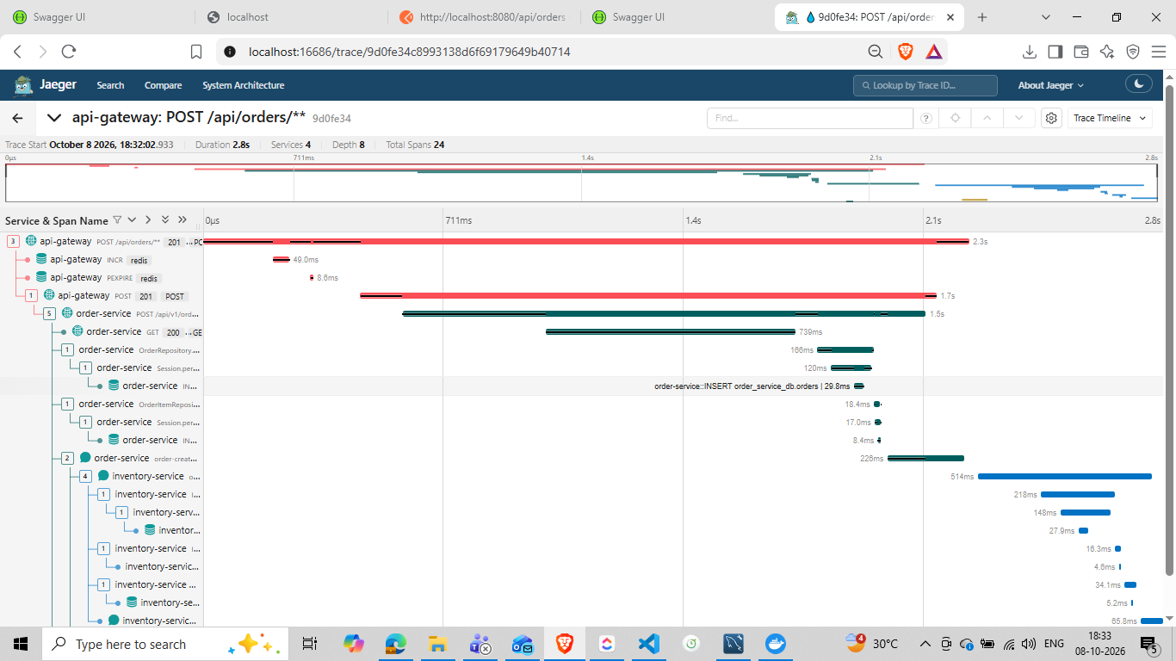
Evidence screenshot — user-provided project evidence.
Interpretation: This evidence is included to show what was actually observed during the implementation/test run; it is not a generic example.

Evidence 04 — Jaeger trace timeline and database spans
Purpose: Inspect the timing and nested database work.
Observed result: The trace timeline shows HTTP, Kafka/application operations and Inventory repository/database spans nested under the distributed request.
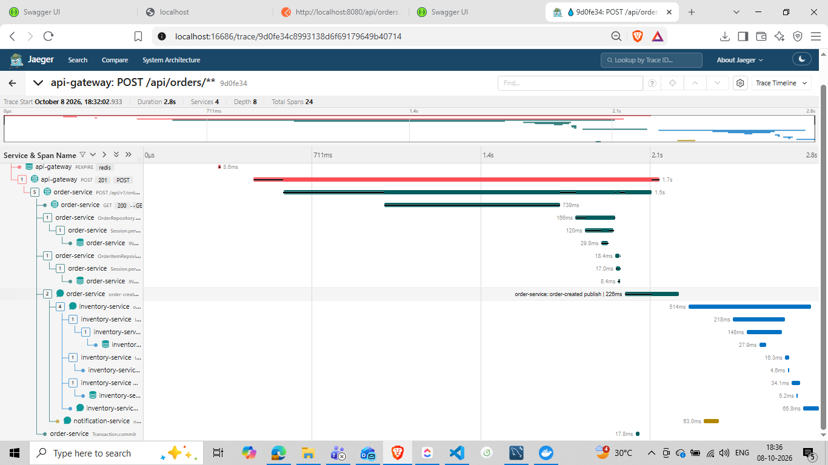
Evidence screenshot — user-provided project evidence.
Interpretation: This evidence is included to show what was actually observed during the implementation/test run; it is not a generic example.

Evidence 05 — Jaeger trace detail
Purpose: Inspect the service/span hierarchy at a different point in the same trace.
Observed result: The screenshot shows the trace tree and individual operations used to diagnose where time was spent.
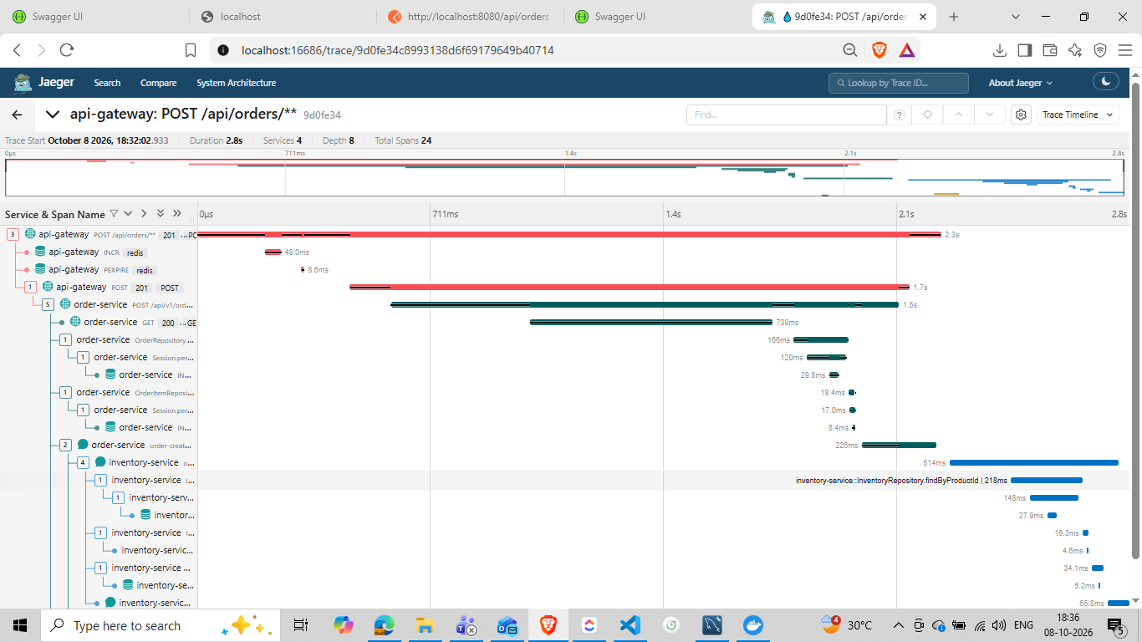
Evidence screenshot — user-provided project evidence.
Interpretation: This evidence is included to show what was actually observed during the implementation/test run; it is not a generic example.

How to read the trace
- Root span: identifies the entry operation, such as api-gateway: POST /api/orders/**.
- Child HTTP span: shows the Order Service endpoint and status.
- Messaging spans: show Kafka producer/consumer activity and topic/destination attributes.
- Database spans: show repository/SQL operations.
- Transaction spans: show commit boundaries.
- Resource attributes identify service/environment/host metadata.
This is the main operational value of distributed tracing: the trace tree provides causality and timing that a flat log stream cannot provide as directly.

18. Inventory State and Payment Completion
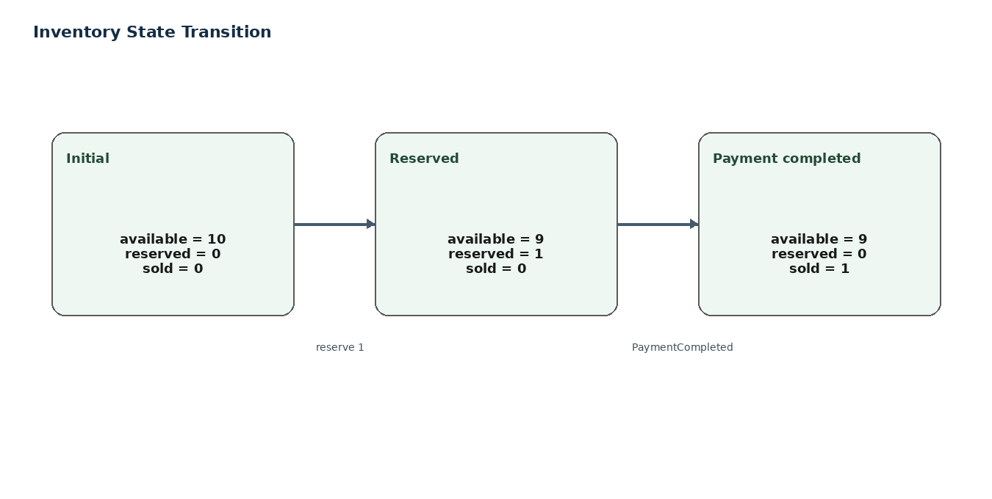
Figure 7 — Inventory lifecycle used in the tested order flow.
The Inventory model was enhanced with soldQuantity so the business lifecycle is visible as three distinct quantities:
State | Available | Reserved | Sold
Initial test state | 10 | 0 | 0
After reservation of 1 | 9 | 1 | 0
After payment completion of 1 | 9 | 0 | 1
The database evidence below is a later accumulated test state, not the initial state. It shows available=5, reserved=0 and sold=5 for product 1, demonstrating that successful payment completion has been reflected in sold quantity.

Evidence 06 — Inventory database state
Purpose: Verify the persisted inventory lifecycle state.
Observed result: MySQL Workbench shows product_id 1 with available_quantity 5, reserved_quantity 0 and sold_quantity 5.
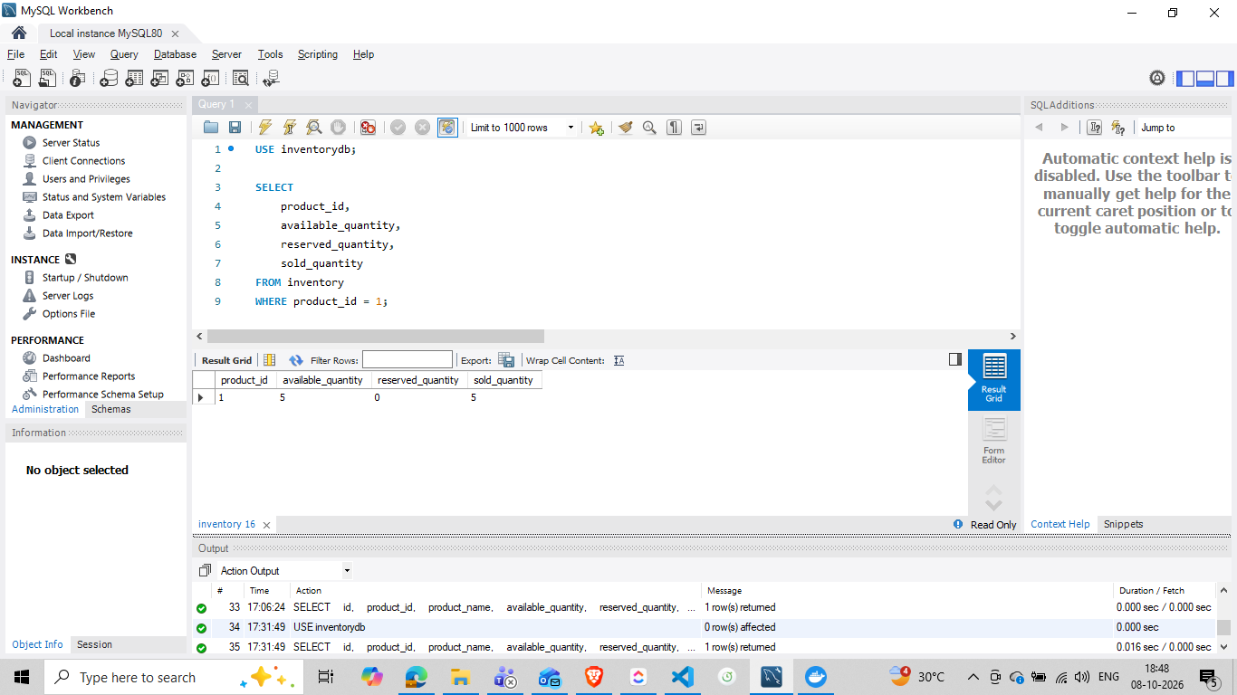
Evidence screenshot — user-provided project evidence.
Interpretation: This evidence is included to show what was actually observed during the implementation/test run; it is not a generic example.

Evidence 07 — Order database state after recovery
Purpose: Verify the final order state after PaymentCompleted processing.
Observed result: MySQL Workbench shows order 16423 with status CONFIRMED.
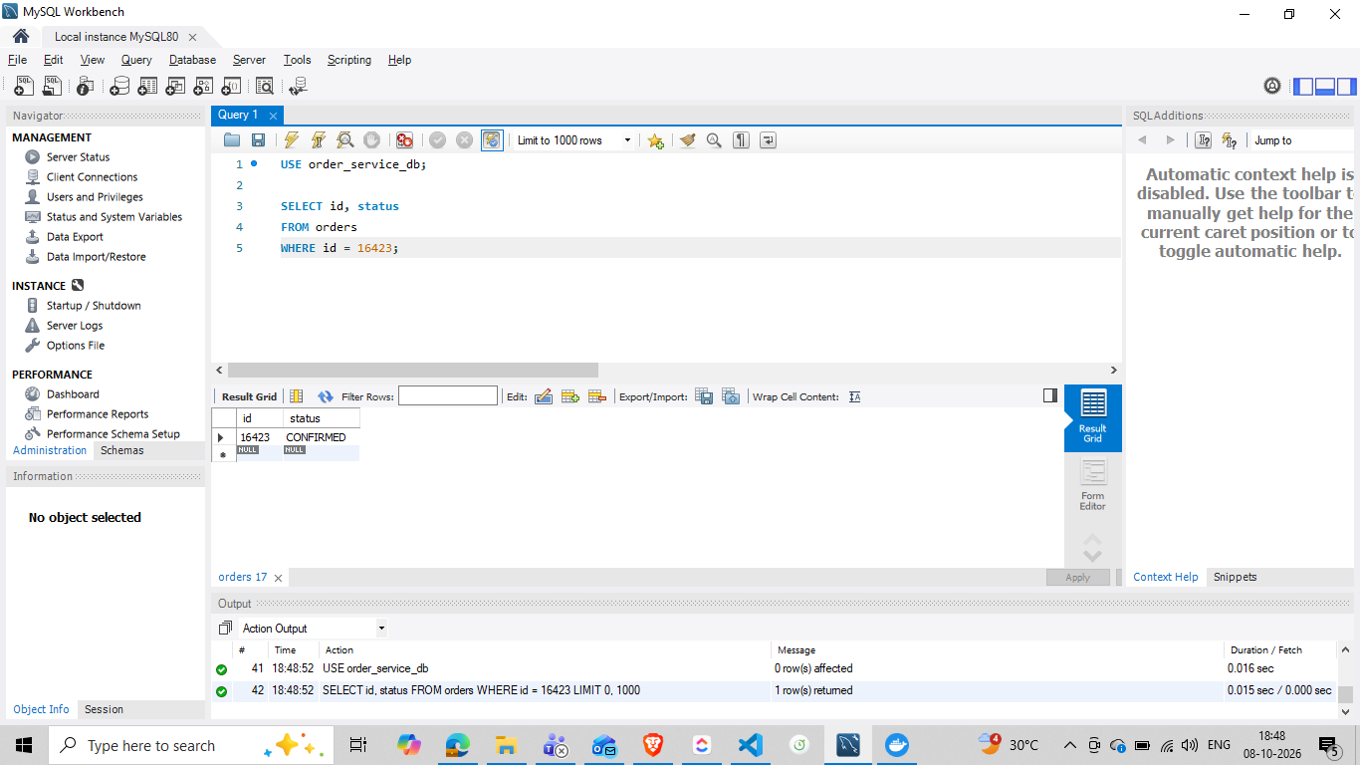
Evidence screenshot — user-provided project evidence.
Interpretation: This evidence is included to show what was actually observed during the implementation/test run; it is not a generic example.

19. Failure and Recovery Workflow
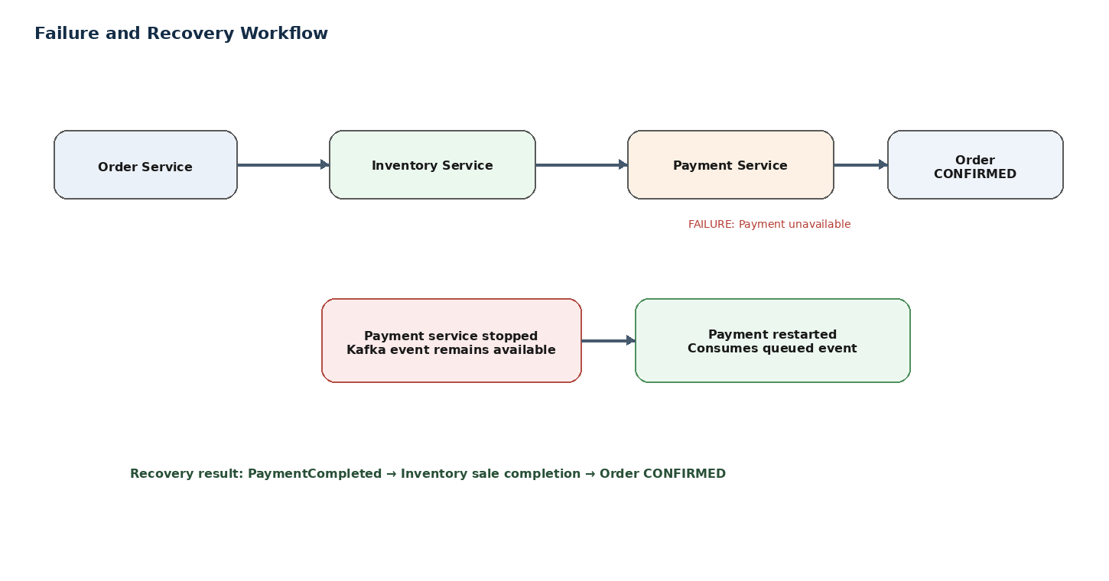
Figure 8 — Asynchronous payment failure/recovery workflow.
The failure scenario used correlation ID OTEL-FAILURE-001. The key architectural behavior is that order creation is asynchronous with respect to payment completion: the initial HTTP request can return 201 while payment processing is still pending.
When Payment Service is unavailable, the event remains available for later consumption. After the service is restarted, it can consume the queued event, publish PaymentCompleted, and allow Inventory and Order to finish their downstream work.

Evidence 08 — Order Service failure/recovery logs
Purpose: Show correlation-aware Order Service logs across successful and failure test cases.
Observed result: The terminal shows OTEL-GATEWAY-TEST-002 and OTEL-FAILURE-001, including PaymentCompleted receipt and Order confirmed after payment.
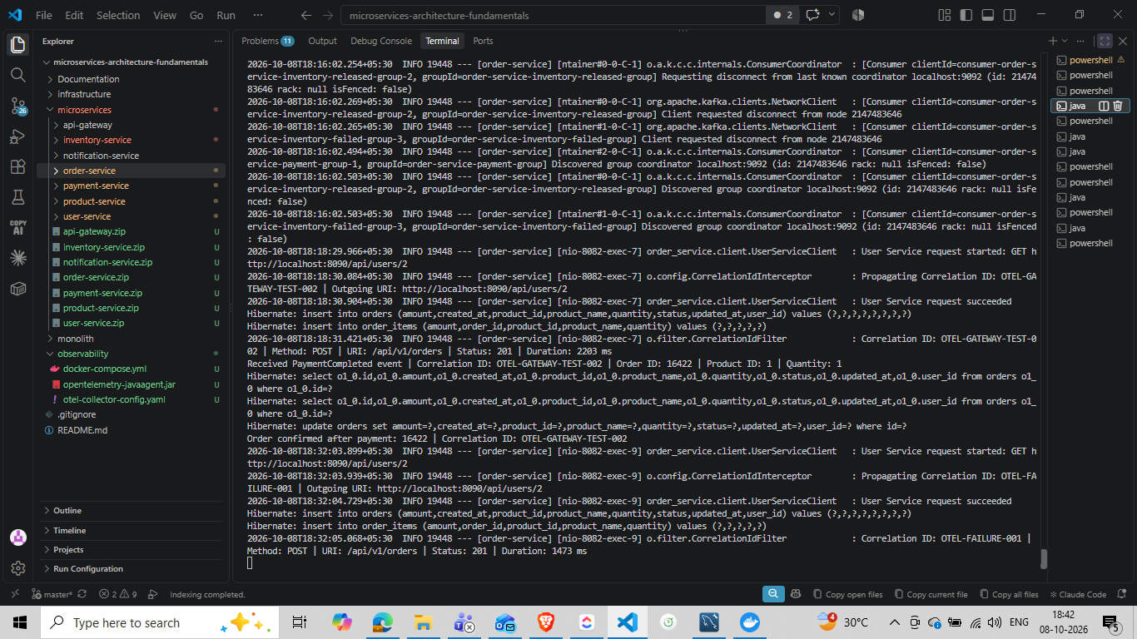
Evidence screenshot — user-provided project evidence.
Interpretation: This evidence is included to show what was actually observed during the implementation/test run; it is not a generic example.

Evidence 09 — Payment Service recovery/publish evidence
Purpose: Show the Payment Service publishing PaymentCompleted after processing.
Observed result: The terminal shows Payment Service Kafka producer activity and Published PaymentCompleted event for OTEL-FAILURE-001 / Order 16423.
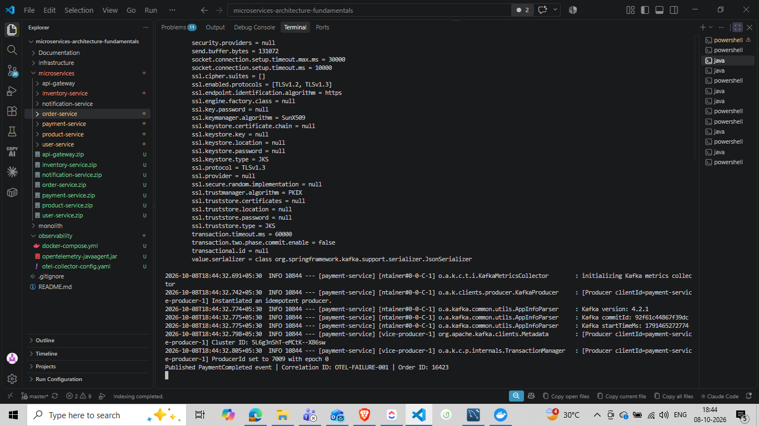
Evidence screenshot — user-provided project evidence.
Interpretation: This evidence is included to show what was actually observed during the implementation/test run; it is not a generic example.

Evidence 10 — Inventory recovery log
Purpose: Show Inventory receiving an order after the failure test and maintaining the correlation ID.
Observed result: The terminal shows OTEL-FAILURE-001 and the subsequent inventory reservation activity.
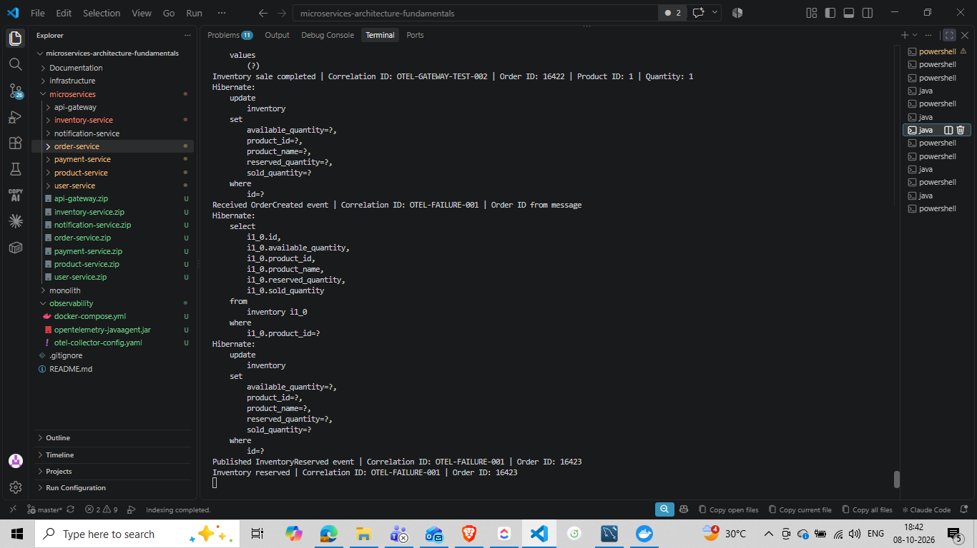
Evidence screenshot — user-provided project evidence.
Interpretation: This evidence is included to show what was actually observed during the implementation/test run; it is not a generic example.

20. Payment Completion Idempotency
Asynchronous messaging can result in duplicate delivery or repeated processing attempts. To make PaymentCompleted processing safe, the Inventory Service records processed payment completions in a dedicated persistence model.
PaymentCompleted
↓
findByOrderId(...)
↓
already processed? ── yes → ignore duplicate
│
no
↓
completeSale(...)
↓
save processed completion

Evidence 11 — Payment completion idempotency in logs/trace context
Purpose: Show repository operations associated with processed payment completion.
Observed result: The captured terminal/trace evidence includes ProcessedPaymentCompletion repository activity and the sale-completion update path.
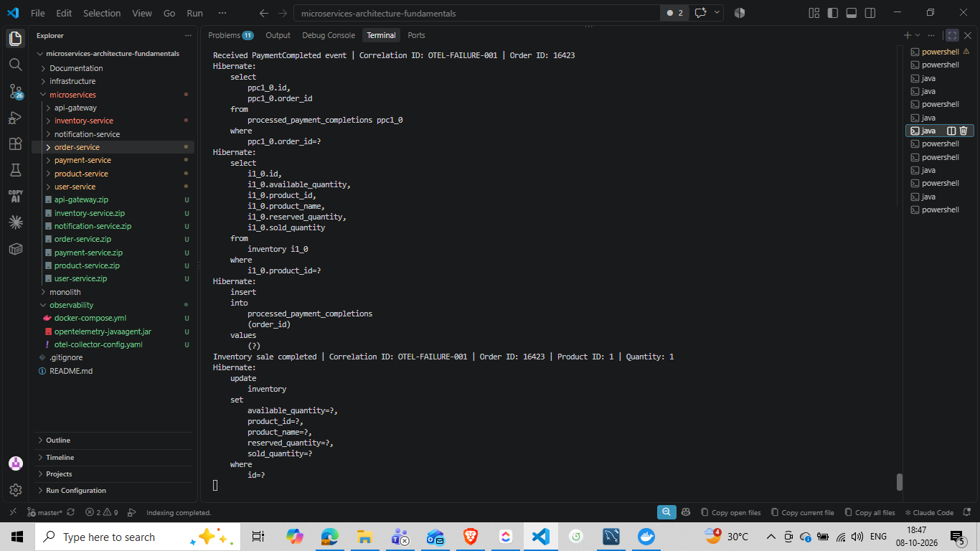
Evidence screenshot — user-provided project evidence.
Interpretation: This evidence is included to show what was actually observed during the implementation/test run; it is not a generic example.
This is a business reliability safeguard rather than an OpenTelemetry feature. It is documented here because the trace makes the safeguard observable and testable.

21. Testing and Validation
Test | Expected | Observed | Status
Gateway correlation propagation | Same X-Correlation-ID returned | OTEL-GATEWAY-TEST-002 preserved | PASS
HTTP downstream propagation | Order → User keeps correlation ID | Logs show same ID | PASS
Kafka application correlation | Events retain correlation ID | Inventory/Payment/Order logs show same IDs | PASS
Distributed trace | One trace spans services | Jaeger shows multi-service trace | PASS
Inventory reservation | available decreases, reserved increases | Database/logs confirm | PASS
Payment completion | reserved decreases, sold increases | Inventory sale completed + DB evidence | PASS
Order confirmation | Order becomes CONFIRMED | Order 16423 = CONFIRMED | PASS
Failure recovery | Queued event eventually completes | PaymentCompleted and confirmation observed | PASS
Payment completion idempotency | Duplicate completion does not double-sell | ProcessedPaymentCompletion persistence observed | PASS
Git checkpoint | Clean pushed repository | master up to date | PASS

Evidence 12 — User Service correlation logging
Purpose: Verify that a downstream HTTP service receives the application correlation value.
Observed result: User Service logs show correlation IDs including OTEL-GATEWAY-TEST-002 and OTEL-FAILURE-001.
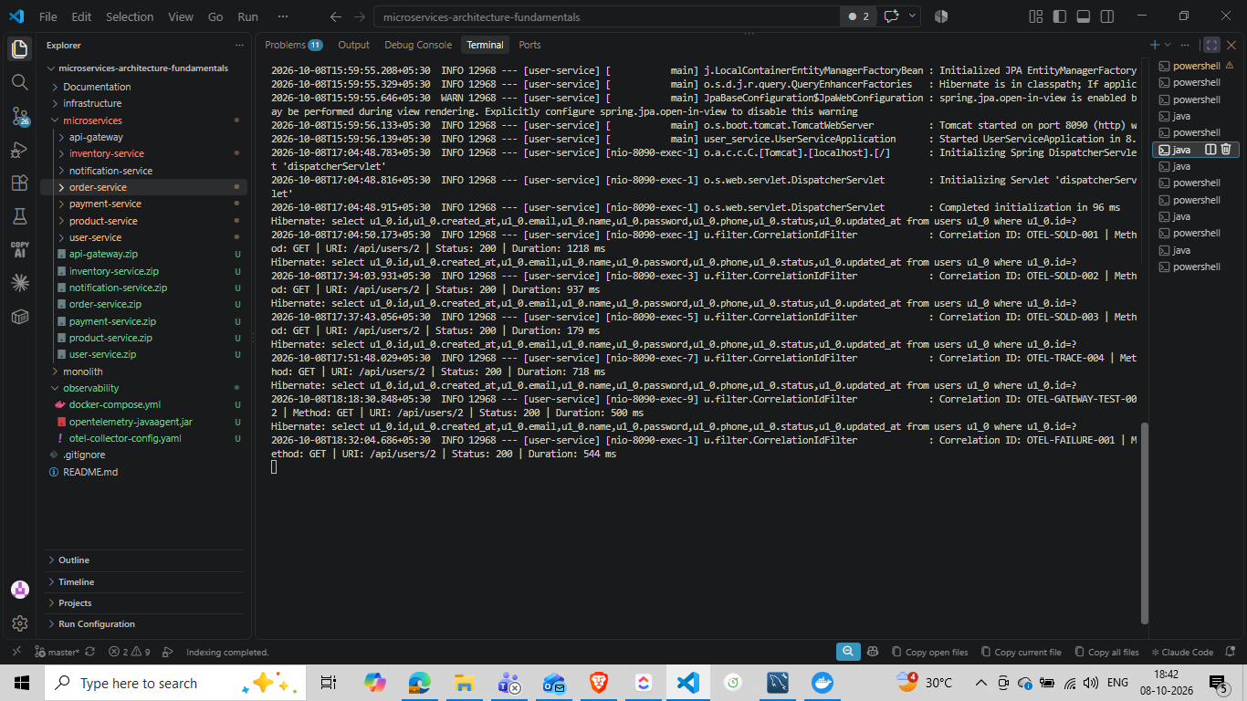
Evidence screenshot — user-provided project evidence.
Interpretation: This evidence is included to show what was actually observed during the implementation/test run; it is not a generic example.

22. Troubleshooting Guide

22.1 No traces in Jaeger
- Confirm Jaeger and the Collector are running.
- Confirm the Java process was started with -javaagent.
- Confirm otel.exporter.otlp.endpoint points to the Collector.
- Confirm the service name is set.
- Use -Dotel.javaagent.debug=true during diagnosis.
- Search Jaeger using the correct service/time window.

22.2 Gateway trace not immediately visible
During the work there was a point where a trace search showed an Order Service root rather than Gateway. The correct response was to diagnose the Gateway agent/instrumentation startup rather than manually rewrite traceparent handling.

Evidence 13 — Gateway OpenTelemetry debug startup
Purpose: Show explicit Java Agent debug instrumentation while diagnosing Gateway tracing.
Observed result: The terminal shows OpenTelemetry instrumentation activity involving Spring Web MVC classes, supporting the decision to diagnose agent instrumentation before adding manual tracing code.
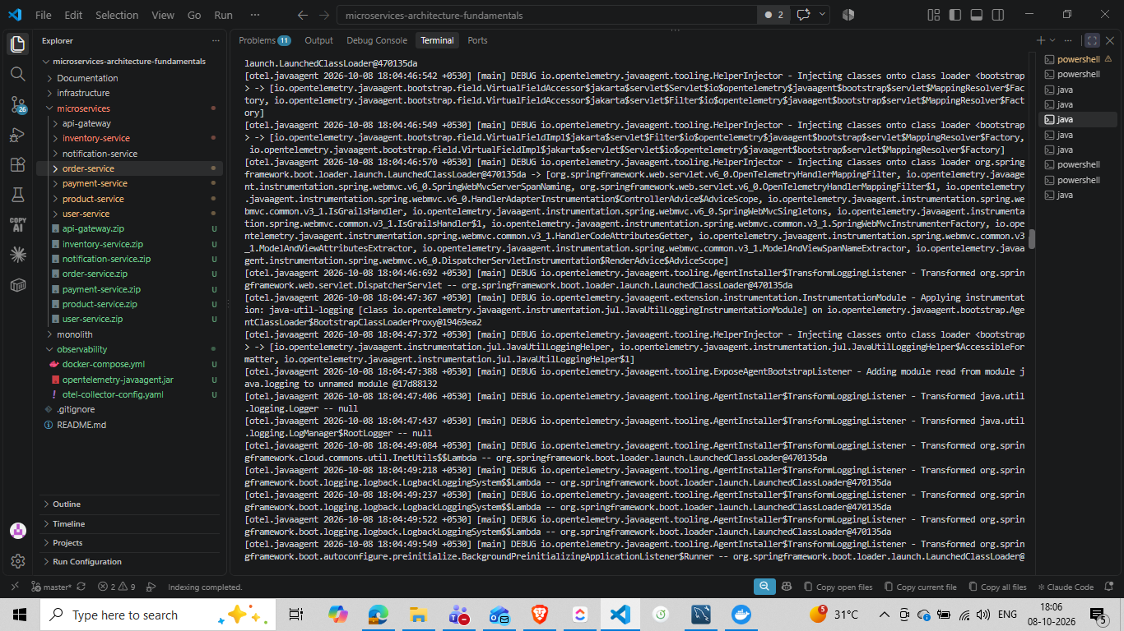
Evidence screenshot — user-provided project evidence.
Interpretation: This evidence is included to show what was actually observed during the implementation/test run; it is not a generic example.

22.3 Port 8080 already in use

Evidence 14 — Gateway port conflict
Purpose: Document a real startup problem encountered during the work.
Observed result: Spring Boot reported that port 8080 was already in use. The troubleshooting approach was to identify and stop the process occupying the port before restarting Gateway.
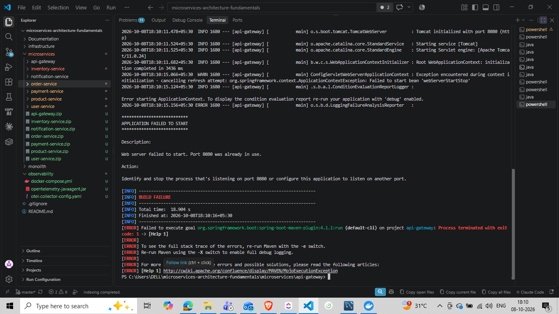
Evidence screenshot — user-provided project evidence.
Interpretation: This evidence is included to show what was actually observed during the implementation/test run; it is not a generic example.

22.4 Redis instrumentation error in a trace

Evidence 15 — Redis client error visible as a span
Purpose: Show how Jaeger can reveal non-business infrastructure errors.
Observed result: The span reports an unknown Redis command. This is useful evidence that tracing can expose infrastructure/client-level failures; it should not be confused with an order-processing failure.
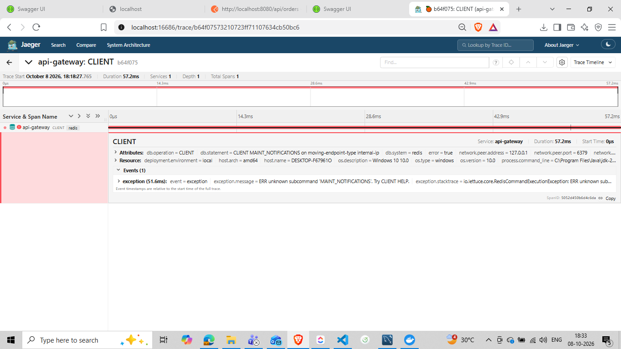
Evidence screenshot — user-provided project evidence.
Interpretation: This evidence is included to show what was actually observed during the implementation/test run; it is not a generic example.

22.5 Kafka consumer instability
Several terminal captures contain Kafka coordinator reconnect/recovery messages. These should be interpreted separately from application-level PaymentCompleted success. Kafka may reconnect while the consumer eventually resumes processing. Correlation IDs and final database state provide the stronger business-level validation.

23. Git / Version-Control Checkpoint
The completed observability work was committed before continuing with the next task. The OpenTelemetry Java Agent JAR was deliberately excluded from Git because it is a binary runtime artifact; the project retains the configuration needed to use it.

Evidence 16 — Git staging checkpoint
Purpose: Show the files staged for the observability implementation.
Observed result: The staged set includes source changes, observability Docker/Collector configuration and .gitignore; the agent JAR is not staged.
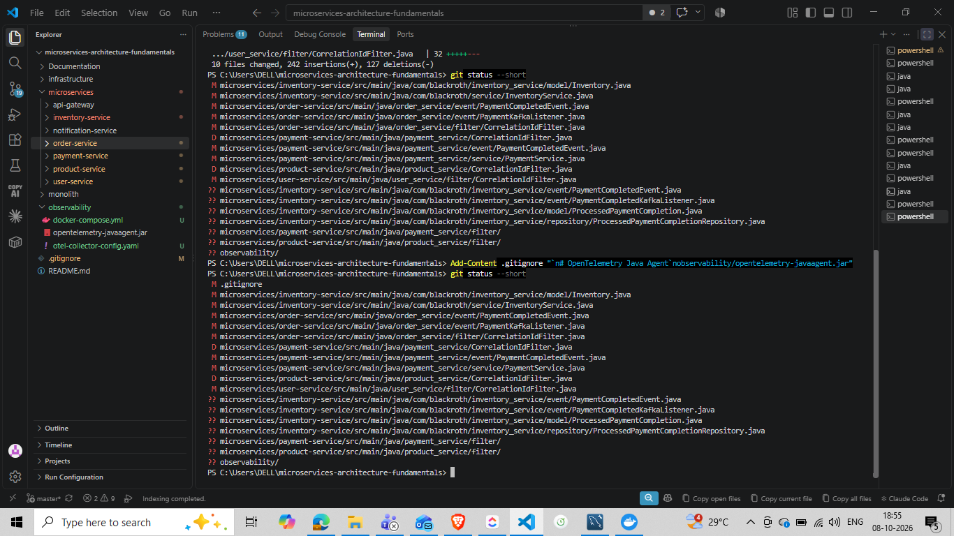
Evidence screenshot — user-provided project evidence.
Interpretation: This evidence is included to show what was actually observed during the implementation/test run; it is not a generic example.

Evidence 17 — Git commit
Purpose: Show the successful local commit.
Observed result: Commit 5b514af was created with message feat: add OpenTelemetry distributed tracing; Git reports 17 files changed.
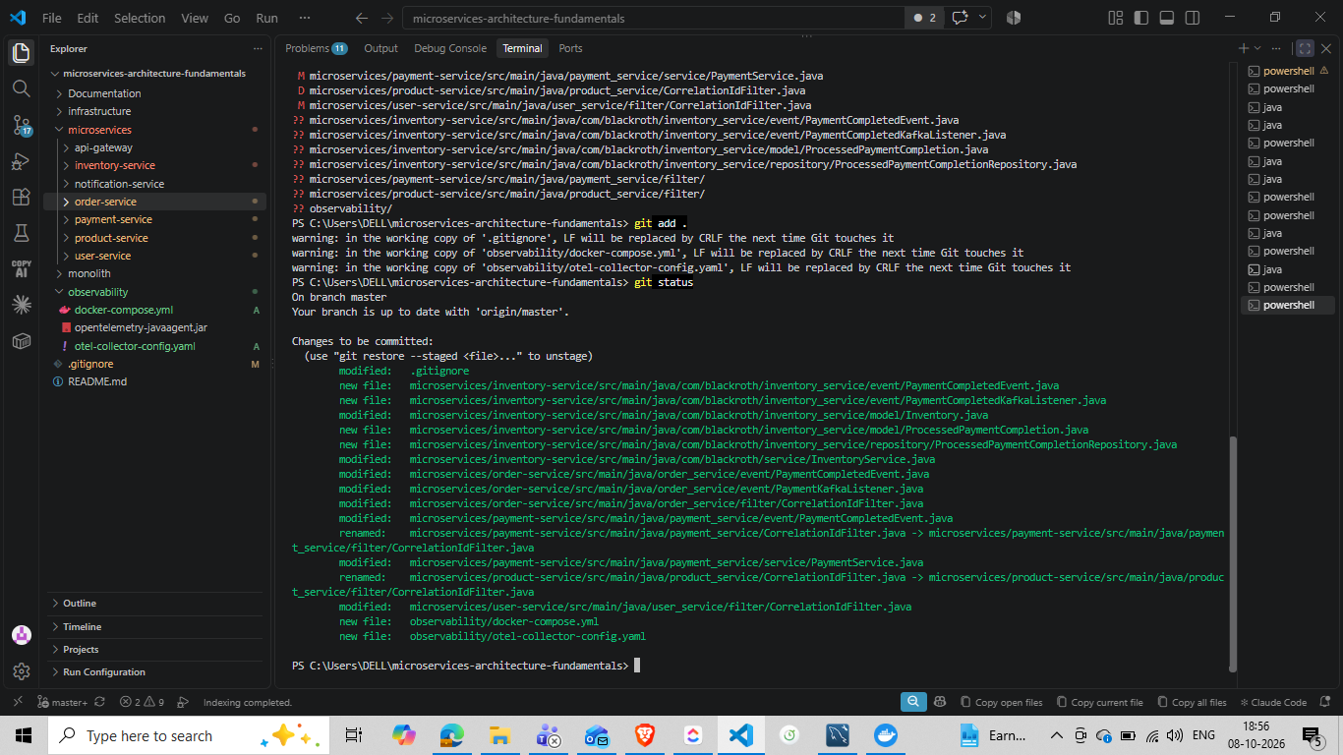
Evidence screenshot — user-provided project evidence.
Interpretation: This evidence is included to show what was actually observed during the implementation/test run; it is not a generic example.

Evidence 18 — Git push and clean working tree
Purpose: Show that the checkpoint was pushed to GitHub.
Observed result: Git reports master is up to date with origin/master and the working tree is clean.
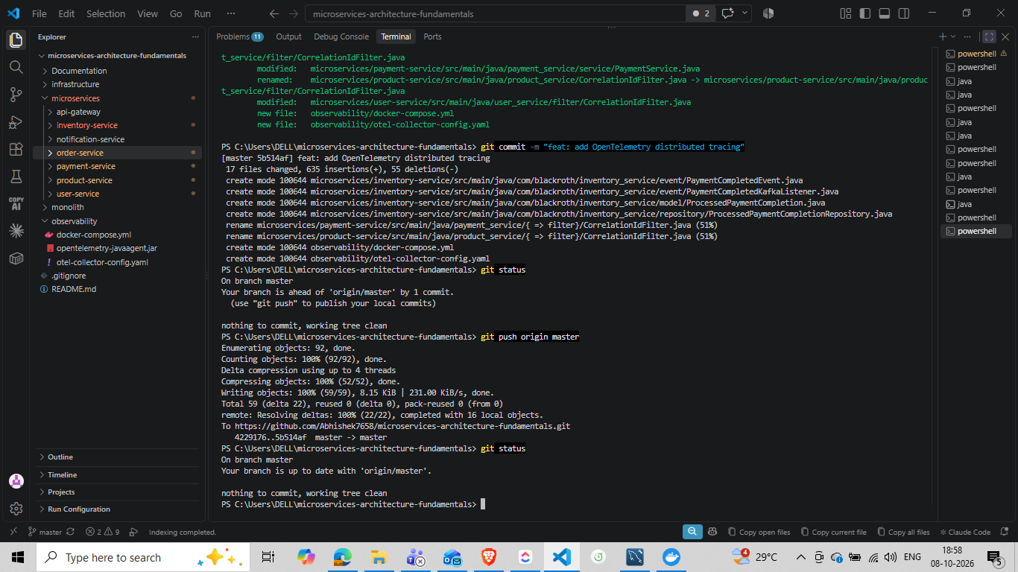
Evidence screenshot — user-provided project evidence.
Interpretation: This evidence is included to show what was actually observed during the implementation/test run; it is not a generic example.

24. Completion Status
Deliverable | Status | Evidence / note
Distributed tracing concept understood | COMPLETE | Concept sections + Jaeger evidence
Correlation ID generation/propagation | COMPLETE | Postman + service logs
Structured-style logging | COMPLETE | Gateway/service terminal evidence
HTTP trace propagation | COMPLETE | Jaeger HTTP spans
Kafka trace propagation | COMPLETE | Jaeger messaging spans + logs
OpenTelemetry Java Agent | COMPLETE | Agent debug/startup evidence
OTLP pipeline | COMPLETE | Collector/Jaeger configuration used in project
Jaeger visualization | COMPLETE | Multi-service traces captured
Failure and recovery | COMPLETE | OTEL-FAILURE-001 logs + DB confirmation
Inventory sold quantity | COMPLETE | MySQL evidence
Payment completion idempotency | COMPLETE | ProcessedPaymentCompletion evidence
GitHub checkpoint | COMPLETE | Commit 5b514af pushed

25. Glossary
Term | Meaning
Observability | Ability to understand system behavior through telemetry such as traces, logs and metrics.
Trace | Complete distributed journey of one logical operation.
Span | One operation inside a trace.
Trace ID | Identifier of the complete trace.
Span ID | Identifier of one span.
Correlation ID | Application-level identifier used to correlate logs/messages.
traceparent | W3C Trace Context header carrying trace context.
OpenTelemetry | Vendor-neutral framework for generating and exporting telemetry.
Java Agent | Runtime instrumentation agent that can create telemetry with minimal code changes.
OTLP | OpenTelemetry Protocol used to transport telemetry.
Collector | Receives, processes and exports OpenTelemetry telemetry.
Jaeger | Distributed tracing backend/UI used to inspect traces.
Propagation | Passing context from one process/component to another.
Structured logging | Logging with consistent, predictable fields.
Kafka | Asynchronous event streaming/message broker used between services.

26. Final Summary
Task 04 transformed the BlackRoth microservices system from a collection of independently logged services into an observable distributed workflow. The implementation preserves application-level X-Correlation-ID for business troubleshooting while using OpenTelemetry for technical trace/span context.
The most important practical outcome is that a single order can now be examined from multiple perspectives: Postman shows the external result, application logs show business correlation, Kafka logs show asynchronous processing, Jaeger shows the distributed span tree and MySQL shows the final business state.
The implementation was tested with successful and failure/recovery scenarios, including inventory state transitions and payment completion idempotency. The work was committed as 5b514af and pushed to origin/master with a clean working tree.
This document is intentionally written as both formal task documentation and a learning reference. A future reader should be able to start with the concepts, follow the architecture, reproduce the workflow, interpret the evidence and troubleshoot the system without needing to reconstruct the reasoning from chat history.

Appendix A — Evidence Register
ID | Evidence | Source screenshot
01 | OpenTelemetry Java Agent debug instrumentation | image_31.png
02 | Successful Postman order request | image_29.png
03 | Jaeger multi-service trace | image_3.png
04 | Jaeger timeline/database spans | image_4.png
05 | Jaeger trace detail | image_5.png
06 | Inventory database state | image_16.png
07 | Order database state | image_17.png
08 | Order failure/recovery logs | image_13.png
09 | PaymentCompleted publication | image_14.png
10 | Inventory recovery/reservation log | image_11.png
11 | Payment completion idempotency evidence | image_9.png
12 | User Service correlation logging | image_12.png
13 | Gateway OTel debug instrumentation | image_24.png
14 | Gateway port conflict troubleshooting | image_26.png
15 | Redis client error visible in trace | image_2.png
16 | Git staging checkpoint | image_20.png
17 | Git commit | image_21.png
18 | Git push / clean tree | image_23.png

Appendix B — Key Configuration

OpenTelemetry Collector
receivers:
otlp:
protocols:
grpc:
endpoint: 0.0.0.0:4317
http:
endpoint: 0.0.0.0:4318
processors:
batch:
exporters:
otlp/jaeger:
endpoint: jaeger:4317
tls:
insecure: true
service:
pipelines:
traces:
receivers: [otlp]
processors: [batch]
exporters: [otlp/jaeger]

Local observability containers
Jaeger:
image: cr.jaegertracing.io/jaegertracing/jaeger:2.21.0
UI: 16686
OpenTelemetry Collector:
image: otel/opentelemetry-collector:0.162.0
OTLP gRPC: 4317
OTLP HTTP: 4318

Representative service startup
-javaagent:<path>\opentelemetry-javaagent.jar
-Dotel.service.name=<service-name>
-Dotel.exporter.otlp.endpoint=http://localhost:4317
-Dotel.exporter.otlp.protocol=grpc
-Dotel.resource.attributes=service.namespace=blackroth,deployment.environment=local
-Dotel.logs.exporter=none
-Dotel.metrics.exporter=none

The exact runtime path is machine-specific. The project intentionally ignores observability/opentelemetry-javaagent.jar in Git.

Appendix C — Reproduction Checklist
- Start Kafka and required MySQL/Redis infrastructure.
- Start observability/docker-compose.yml.
- Confirm Collector ports 4317/4318 and Jaeger UI 16686 are available.
- Start services with the OpenTelemetry Java Agent and service-specific names.
- Send POST /api/orders from Postman with a new X-Correlation-ID and Idempotency-Key.
- Record the HTTP status and response correlation header.
- Search Jaeger by service and time window.
- Open the trace and inspect the HTTP, Kafka and database spans.
- Check Inventory quantities in MySQL.
- Check Order status in MySQL.
- Repeat with a controlled Payment Service failure if failure/recovery evidence is required.
- After recovery, verify PaymentCompleted, Inventory sale completion and Order CONFIRMED.
- Use a new Idempotency-Key for each new order test.
- Commit and push changes after reaching a stable checkpoint.

Document Integrity Note
Evidence in this document comes from screenshots and implementation results supplied during the BlackRoth Task 04 work. Claims are intentionally limited to what those observations and the project implementation support. Where a screenshot shows an error, it is labeled as troubleshooting evidence rather than presented as a successful result.

Presenter Runbook — Execute EPIC 07 Task 04 from Start to Finish
This section is the practical presentation guide for demonstrating Task 04 to another person. Follow it in order: infrastructure → observability → application services → Postman → MySQL → Jaeger → failure/recovery → evidence. The commands are written for Windows PowerShell and the project layout used by BlackRoth.
Presentation rule: use a NEW Idempotency-Key and a NEW X-Correlation-ID for every new order request. Do not reuse a previous successful idempotency key, otherwise the earlier stored response can be returned by the idempotency layer.

A. What You Need Before Starting
Requirement | Expected
Project root | C:\Users\DELL\microservices-architecture-fundamentals
Java | Java 25
Spring Boot | 4.1.1
Maven | Project Maven Wrapper (mvnw.cmd)
Docker | Docker Desktop running
Postman | Available for HTTP testing
MySQL | Available through the project's infrastructure
Kafka | Available through the project's infrastructure
Redis | Available through the project's infrastructure
Jaeger UI | http://localhost:16686
OpenTelemetry Collector | localhost:4317 / localhost:4318
Agent | observability\opentelemetry-javaagent.jar

B. Target Architecture to Explain Before the Demo
Explain the demo in one sentence:
“A request enters through the API Gateway, becomes a distributed trace, travels through Order/Inventory/Payment using HTTP and Kafka, updates MySQL business state, and can then be inspected in Jaeger using the trace tree.”
Postman
|
| HTTP + X-Correlation-ID
v
API Gateway :8080
|
v
Order Service :8082
|---- HTTP ----> User Service :8090
|
| Kafka: order-created
v
Inventory Service :8085
|
| Kafka: inventory-reserved
v
Payment Service :8084
|
| Kafka: payment-completed
+----------------------+
|
v
Inventory sale completion
|
v
Order CONFIRMED
All instrumented services
|
| OTLP
v
OpenTelemetry Collector :4317/:4318
|
v
Jaeger :16686

C. Step 1 — Open PowerShell Windows
Use separate PowerShell windows so each service's logs remain visible during the presentation.
- PowerShell 1 — Infrastructure / Docker
- PowerShell 2 — OpenTelemetry Collector + Jaeger
- PowerShell 3 — API Gateway
- PowerShell 4 — Order Service
- PowerShell 5 — User Service
- PowerShell 6 — Inventory Service
- PowerShell 7 — Payment Service
- PowerShell 8 — Postman / MySQL / Jaeger observation

D. Step 2 — Start Application Infrastructure
From the project root, start the infrastructure defined by the project's Docker Compose setup.
cd C:\Users\DELL\microservices-architecture-fundamentals
docker compose up -d
docker compose ps

Expected result: the required infrastructure containers are running. Confirm that Kafka, MySQL and Redis are available before starting the Spring Boot services. If your project keeps Kafka infrastructure under infrastructure\Kafka, use that compose file instead of starting the root stack twice.
# If Kafka is maintained under infrastructure\Kafka in your checkout:
cd C:\Users\DELL\microservices-architecture-fundamentals\infrastructure\Kafka
docker compose up -d
docker compose ps

Do not run both compose stacks blindly if the root stack already starts the same containers; duplicate port mappings can cause conflicts.

E. Step 3 — Start OpenTelemetry Collector and Jaeger
Open a new PowerShell window.
cd C:\Users\DELL\microservices-architecture-fundamentals\observability
docker compose config
docker compose up -d
docker compose ps

Expected result:
blackroth-jaeger Up 16686
blackroth-otel-collector Up 4317, 4318

Open Jaeger before sending the test request so the UI is ready to receive the trace.
http://localhost:16686

Keep the Jaeger browser tab open during the presentation.

F. Step 4 — Verify the OpenTelemetry Agent
The project uses the OpenTelemetry Java Agent rather than adding OTel dependencies directly to every service.
cd C:\Users\DELL\microservices-architecture-fundamentals\observability
Get-Item .\opentelemetry-javaagent.jar | Select-Object Name,Length

The file should exist and have a non-trivial size. When a service starts, look for a line similar to:
[otel.javaagent ...] INFO ... opentelemetry-javaagent - version: 2.32.0

G. Step 5 — Build the Services
Build each service before starting the packaged JAR. Run the Maven Wrapper from each service directory.
Service | Directory
API Gateway | api-gateway
User Service | user-service
Product Service | product-service
Order Service | order-service
Payment Service | payment-service
Inventory Service | inventory-service
Notification Service | notification-service
cd C:\Users\DELL\microservices-architecture-fundamentals\api-gateway
.\mvnw.cmd clean package -DskipTests
cd ..\user-service
.\mvnw.cmd clean package -DskipTests
cd ..\product-service
.\mvnw.cmd clean package -DskipTests
cd ..\order-service
.\mvnw.cmd clean package -DskipTests
cd ..\payment-service
.\mvnw.cmd clean package -DskipTests
cd ..\inventory-service
.\mvnw.cmd clean package -DskipTests
cd ..\notification-service
.\mvnw.cmd clean package -DskipTests

If a module does not produce the expected JAR, inspect its target directory with Get-ChildItem target\*.jar and use the actual generated filename. Do not guess a filename if the project version has changed.

H. Step 6 — Start API Gateway with OpenTelemetry
cd C:\Users\DELL\microservices-architecture-fundamentals\api-gateway
java "-javaagent:C:\Users\DELL\microservices-architecture-fundamentals\observability\opentelemetry-javaagent.jar" `
"-Dotel.service.name=api-gateway" `
"-Dotel.exporter.otlp.endpoint=http://localhost:4317" `
"-Dotel.exporter.otlp.protocol=grpc" `
"-Dotel.resource.attributes=service.namespace=blackroth,deployment.environment=local" `
"-Dotel.logs.exporter=none" `
"-Dotel.metrics.exporter=none" `
"-jar" "target\api-gateway-0.0.1-SNAPSHOT.jar"

Expected: Spring Boot starts on port 8080 and the OpenTelemetry Java Agent reports version 2.32.0.
For Gateway instrumentation diagnosis, add this option only when troubleshooting:
"-Dotel.javaagent.debug=true"

I. Step 7 — Start Order Service with OpenTelemetry
cd C:\Users\DELL\microservices-architecture-fundamentals\order-service
java "-javaagent:C:\Users\DELL\microservices-architecture-fundamentals\observability\opentelemetry-javaagent.jar" `
"-Dotel.service.name=order-service" `
"-Dotel.exporter.otlp.endpoint=http://localhost:4317" `
"-Dotel.exporter.otlp.protocol=grpc" `
"-Dotel.resource.attributes=service.namespace=blackroth,deployment.environment=local" `
"-Dotel.logs.exporter=none" `
"-Dotel.metrics.exporter=none" `
"-jar" "target\order-service-0.0.1-SNAPSHOT.jar"

Expected: Order Service starts on port 8082 and connects to its MySQL database and Kafka.

J. Step 8 — Start User Service
cd C:\Users\DELL\microservices-architecture-fundamentals\user-service
java "-javaagent:C:\Users\DELL\microservices-architecture-fundamentals\observability\opentelemetry-javaagent.jar" `
"-Dotel.service.name=user-service" `
"-Dotel.exporter.otlp.endpoint=http://localhost:4317" `
"-Dotel.exporter.otlp.protocol=grpc" `
"-Dotel.resource.attributes=service.namespace=blackroth,deployment.environment=local" `
"-Dotel.logs.exporter=none" `
"-Dotel.metrics.exporter=none" `
"-jar" "target\user-service-0.0.1-SNAPSHOT.jar"

Expected: User Service starts on port 8090.

K. Step 9 — Start Inventory Service
cd C:\Users\DELL\microservices-architecture-fundamentals\inventory-service
java "-javaagent:C:\Users\DELL\microservices-architecture-fundamentals\observability\opentelemetry-javaagent.jar" `
"-Dotel.service.name=inventory-service" `
"-Dotel.exporter.otlp.endpoint=http://localhost:4317" `
"-Dotel.exporter.otlp.protocol=grpc" `
"-Dotel.resource.attributes=service.namespace=blackroth,deployment.environment=local" `
"-Dotel.logs.exporter=none" `
"-Dotel.metrics.exporter=none" `
"-jar" "target\inventory-service-0.0.1-SNAPSHOT.jar"

Expected: Inventory Service starts on port 8085 and subscribes to its Kafka topics.

L. Step 10 — Start Payment Service
cd C:\Users\DELL\microservices-architecture-fundamentals\payment-service
java "-javaagent:C:\Users\DELL\microservices-architecture-fundamentals\observability\opentelemetry-javaagent.jar" `
"-Dotel.service.name=payment-service" `
"-Dotel.exporter.otlp.endpoint=http://localhost:4317" `
"-Dotel.exporter.otlp.protocol=grpc" `
"-Dotel.resource.attributes=service.namespace=blackroth,deployment.environment=local" `
"-Dotel.logs.exporter=none" `
"-Dotel.metrics.exporter=none" `
"-jar" "target\payment-service-0.0.1-SNAPSHOT.jar"

Expected: Payment Service starts on port 8084 and subscribes to inventory-reserved.

M. Step 11 — Optional Services for the Demo
Product and Notification are part of the architecture. Start them when your presentation needs to demonstrate those routes/consumers. They are not required for the core Order → Inventory → Payment tracing demonstration if Notification is already running from your normal project setup.
For any service not listed above, use the same agent pattern and set a unique service name matching the Spring Boot service.

N. Step 12 — Pre-Test Verification
Before sending the order, confirm the main services are listening on their expected ports.
Test-NetConnection localhost -Port 8080
Test-NetConnection localhost -Port 8082
Test-NetConnection localhost -Port 8084
Test-NetConnection localhost -Port 8085
Test-NetConnection localhost -Port 8090
Test-NetConnection localhost -Port 4317
Test-NetConnection localhost -Port 16686

Expected: TcpTestSucceeded = True for the services that are running.
Then open:
http://localhost:16686

O. Step 13 — Prepare MySQL Before the Test
Use MySQL Workbench or the MySQL CLI. The project uses separate databases for services. For the inventory demonstration, select inventorydb.
USE inventorydb;
SELECT id,
product_id,
product_name,
available_quantity,
reserved_quantity,
sold_quantity
FROM inventory
WHERE product_id = 1;

For a clean demonstration, the intended starting state used during the Task 04 test was:
product_id = 1
available_quantity = 10
reserved_quantity = 0
sold_quantity = 0

If you intentionally reset the demonstration row before presenting, use:
UPDATE inventory
SET available_quantity = 10,
reserved_quantity = 0,
sold_quantity = 0
WHERE product_id = 1;
SELECT id, product_id, available_quantity, reserved_quantity, sold_quantity
FROM inventory
WHERE product_id = 1;

Only perform the reset when you are sure product 1 is the dedicated test data. Do not reset production/shared data.

P. Step 14 — Prepare the Postman Request
Create a POST request:
POST http://localhost:8080/api/orders

Headers:
Header | Value
Content-Type | application/json
X-Correlation-ID | OTEL-GUIDE-001
Idempotency-Key | ORD-20261008-GUIDE-001
Body → raw → JSON:
{
"userId": 2,
"productId": 1,
"productName": "Test Product",
"quantity": 1,
"amount": 100
}

Important: if you run the demonstration again, change BOTH OTEL-GUIDE-001 and ORD-20261008-GUIDE-001 to new values.

Q. Step 15 — Send the Successful Request
- Click Send in Postman.
- Confirm HTTP 201 Created.
- Confirm the response contains X-Correlation-Id: OTEL-GUIDE-001.
- Record the returned order ID. Use that order ID for the MySQL verification.
- Keep the response visible while explaining that the HTTP request only represents the synchronous portion of the workflow; Kafka processing can continue after the 201 response.
The expected business flow is:
POST /api/orders
-> Order created
-> order-created
-> Inventory reserved
-> inventory-reserved
-> Payment completed
-> payment-completed
-> Inventory sold quantity updated
-> Order CONFIRMED

R. Step 16 — Watch the Application Logs
During the request, point to the terminals in this order:
Terminal | What to point out
Gateway | X-Correlation-ID, POST /api/orders, status 201, response time.
Order | Order creation, correlation ID, order-created publication, PaymentCompleted receipt.
Inventory | OrderCreated receipt, reservation, InventoryReserved publication, PaymentCompleted sale completion.
Payment | InventoryReserved receipt and PaymentCompleted publication.
User | Same correlation ID if Order performs the synchronous User call.
The teaching point is that the same application correlation value lets a presenter visually connect log lines across independent processes.

S. Step 17 — Verify Inventory in MySQL
USE inventorydb;
SELECT id,
product_id,
product_name,
available_quantity,
reserved_quantity,
sold_quantity
FROM inventory
WHERE product_id = 1;

For a quantity-1 successful order starting from 10/0/0, the expected business transition is:
Before: available=10 reserved=0 sold=0
Reserved: available=9 reserved=1 sold=0
Completed: available=9 reserved=0 sold=1

If your row contains accumulated test history rather than the clean starting state, explain the current values instead of claiming they represent the first test.

T. Step 18 — Verify the Order in MySQL
The exact order table schema should be read from the running Order Service database. Start by selecting the database and inspecting the table:
SHOW DATABASES;
USE order_service_db;
SHOW TABLES;
DESCRIBE orders;

Then query the order returned by Postman:
SELECT *
FROM orders
WHERE id = <ORDER_ID_RETURNED_BY_POSTMAN>;

Expected final business status after payment completion: CONFIRMED.
For presentation, explain that MySQL is the source of truth for business state while Jaeger is the source of truth for distributed execution/timing.

U. Step 19 — Open Jaeger and Find the Trace
Open:
http://localhost:16686

In Jaeger:
- Select the api-gateway service if the successful trace includes Gateway.
- Use the recent time window.
- Search for the latest POST /api/orders trace.
- Open the trace.
- Expand the trace tree.
- Identify the service boundaries: API Gateway → Order → Inventory → Payment and the return/event processing path.
- Click individual spans and inspect tags such as HTTP method, route, status code, Kafka destination, consumer group/client metadata and database operations.
A useful presentation sentence is:
“Jaeger shows not only that the order succeeded, but which service and operation performed each part of the distributed workflow.”

V. Step 20 — Explain the Jaeger Trace Tree
Trace area | What to explain
Root HTTP span | The incoming operation and HTTP status.
Order Service | Business order creation and persistence.
Kafka producer | Order Service publishes order-created.
Inventory consumer | Inventory receives order-created and reserves stock.
Kafka producer | Inventory publishes inventory-reserved.
Payment consumer | Payment receives inventory-reserved.
Payment producer | Payment publishes payment-completed.
Inventory consumer | Inventory completes the sale and persists sold quantity.
Order consumer | Order receives PaymentCompleted and confirms the order.
Database spans | Show repository/SQL activity underneath the business operations.
Do not equate every span with a separate service. A single service can produce many spans because one business operation contains HTTP, Kafka, repository and database work.

W. Step 21 — Demonstrate Correlation ID vs Trace ID
Explain the difference while the Jaeger trace is open:
- X-Correlation-ID = application/business tracking value, visible in application logs and Kafka headers.
- Trace ID = OpenTelemetry identifier for the distributed trace, visible in Jaeger.
- Span ID = OpenTelemetry identifier for one operation inside that trace.
- traceparent = W3C propagation format used by OpenTelemetry between supported boundaries.
The application should not manually create traceparent. OpenTelemetry owns the technical trace context.

X. Step 22 — Demonstrate Failure and Recovery
This is the strongest part of the presentation because it demonstrates why distributed tracing is useful rather than merely showing a successful request.
First, prepare another unique request:
X-Correlation-ID: OTEL-GUIDE-FAIL-001
Idempotency-Key: ORD-20261008-GUIDE-FAIL-001

Use the same JSON body:
{
"userId": 2,
"productId": 1,
"productName": "Test Product",
"quantity": 1,
"amount": 100
}

Stop the Payment Service terminal with Ctrl+C immediately before or around the point you want to demonstrate Payment unavailability. Do not stop Kafka.
Send the Postman request through the Gateway.
Expected teaching point: Order creation can return 201 because payment is asynchronous; the downstream payment step is not necessarily complete at the moment the HTTP response is returned.
Observe Order/Inventory logs and then restart Payment Service using the same OTel startup command from Step 10.
After Payment Service restarts, watch for the queued inventory-reserved event to be consumed and PaymentCompleted to be published.
Then verify:
# Order database
USE order_service_db;
SELECT * FROM orders WHERE id = <FAILURE_TEST_ORDER_ID>;
# Inventory database
USE inventorydb;
SELECT id, product_id, available_quantity, reserved_quantity, sold_quantity
FROM inventory
WHERE product_id = 1;

Expected recovery result: the order eventually reaches CONFIRMED and the inventory sale is completed once PaymentCompleted is processed.

Y. Step 23 — Inspect the Failure Trace in Jaeger
- Search Jaeger for the failure test time window and correlation/test context.
- Open the trace associated with the failed/recovered operation.
- Look for the Payment-related span/error or the absence of a successful downstream payment operation during the outage.
- After recovery, identify the later PaymentCompleted processing spans.
- Compare the trace timing with the terminal timestamps and final MySQL state.
The key lesson is that asynchronous systems may have a temporal gap between the HTTP request, the failure and the eventual recovery. Logs, traces and database state together explain that gap.

Z. Step 24 — Verify Payment Completion Idempotency
The Inventory Service uses ProcessedPaymentCompletion persistence to avoid applying the same PaymentCompleted business event more than once.
# Conceptual flow
PaymentCompleted
|
v
find processed completion
|
already exists? ---- yes ---> ignore duplicate
|
no
v
completeSale()
|
v
save processed completion

In Jaeger, look for ProcessedPaymentCompletionRepository operations around PaymentCompleted processing. Explain that this protects business state from duplicate event processing; it is separate from the HTTP Idempotency-Key used for order creation.

AA. Step 25 — Final Presentation Checklist
Checkpoint | Show the audience
1. Infrastructure | docker compose ps
2. Observability | Collector + Jaeger containers
3. Service startup | OTel Java Agent version 2.32.0
4. Postman | POST request, headers and JSON body
5. HTTP result | 201 Created + X-Correlation-Id
6. Logs | Same correlation ID across services
7. MySQL inventory | available/reserved/sold quantities
8. MySQL order | Order status CONFIRMED
9. Jaeger | Trace tree and service spans
10. Failure | Payment Service unavailable
11. Recovery | PaymentCompleted after restart
12. Final state | Order CONFIRMED + inventory sale
13. Git | Commit 5b514af / clean pushed tree

AB. Fast Presentation Script
If you only have 5–10 minutes, use this exact sequence:
- “First I start Kafka/MySQL/Redis and then the OpenTelemetry Collector and Jaeger.”
- “Next I start the Spring Boot services with the OpenTelemetry Java Agent so each service can create and export trace spans.”
- “I send POST /api/orders with a unique X-Correlation-ID and Idempotency-Key.”
- “The request returns 201, and the same correlation ID appears in the Gateway and downstream service logs.”
- “Now I check MySQL: inventory moved from available to reserved and then sold, and the order eventually becomes CONFIRMED.”
- “In Jaeger, I can open the trace and see the distributed span tree across Gateway, Order, Inventory and Payment, including Kafka and database operations.”
- “Finally, I stop Payment Service, submit another order, restart Payment, and show that the queued event is processed and the order recovers to CONFIRMED.”
- “This demonstrates the difference between application correlation and OpenTelemetry distributed tracing, and shows why tracing is useful for troubleshooting asynchronous microservices.”

AC. Clean-Up After the Presentation
# Stop Spring Boot services
# In each service terminal:
Ctrl+C
# Stop observability
cd C:\Users\DELL\microservices-architecture-fundamentals\observability
docker compose down
# Stop project infrastructure only when you are sure it is not needed by other work
cd ..
docker compose down

Do not run docker compose down against shared development infrastructure without checking whether other tasks/services are using it.

AD. Presenter Troubleshooting Quick Reference
Problem | First checks
Port 8080 already in use | Stop old Gateway process; confirm port ownership before restarting.
No Jaeger trace | Check Collector, agent, OTLP endpoint and service startup log.
Agent not visible | Confirm -javaagent is present in the java command and look for [otel.javaagent ...].
Kafka event not processed | Check Kafka container, topic, consumer group and service logs.
Order is CREATED | Payment/inventory asynchronous processing may still be pending; inspect logs and Jaeger before treating it as failure.
Inventory does not change | Check Inventory Service logs and product_id=1 row.
Duplicate order response | Check Idempotency-Key; use a new key for a new demonstration.
Gateway missing from a trace | Verify Gateway was started with the agent, use a fresh request, and search the newest trace before changing code.
Redis error in trace | Treat it as an infrastructure/client span error; inspect the Redis operation and determine whether it affects the business flow.

AE. Important Accuracy Notes for Presenters
- The current application logs are structured-style pipe-delimited logs, not JSON structured logs.
- X-Correlation-ID is an application-level mechanism; it is not the same identifier as the OpenTelemetry Trace ID.
- OpenTelemetry should own W3C traceparent generation and propagation; application code should not manually construct traceparent.
- A 201 response does not necessarily mean the asynchronous payment workflow has already completed.
- MySQL validates business state; Jaeger validates distributed execution and timing.
- The OpenTelemetry Java Agent JAR is a runtime binary and is intentionally not committed to Git.
- Use fresh Idempotency-Key values for every new order test.
- The exact generated JAR filename can change with the project version; verify target\*.jar if necessary.

